xpedx.com Next generation
Order Business Rules Design Document

Authors: Sterling Commerce

Date Created: 03/17/10
Last Updated: 07/06/10
File Name: xpedx Order Business Rules Detail Design v4.0.docC:\Documents and Settings\bfurman\My Documents\Temp\Methodology v1.1\Project Management\TEMPLATE - DOCUMENT - Use Case Definition.doc

Approval Signatures (Mandatory)

Title | Name | Signature | Date | Comments / Issues / Concerns
xpedx Owner(s) | Steve Bugher
xpedx Owner(s) | Cheryl Tullis
Sterling Commerce Owner(s) | Guy Read

Note: The sign off indicates approval of all sections of the document.

Document Revision History

This chart tracks the changes introduced by the revisions to the document as the project progresses through the stages of the System Development Life Cycle (SDLC).

Version | Date | Description (Changes Made) | Author(s)
0.1 | 03/11/2010 | Initial Draft | Sterling
1.0 | 04/23/2010 | Ready to Deliver | Sterling
2.0 | 06/30/2010 | Incorporated review comments from xpedx | Sterling
3.0 | 07/01/2010 | Feedback Incorporated | Sterling
4.0 | 07/06/2010 | Updated Item Type tables based of inputs from xpedx | Sterling

Related or Reference Documents

Document Name | Description | Owner | Location
SCI_Xpedx Solution Definition Document v1.5 | Solution Definition document | Sterling Commerce

TABLE OF CONTENTS

1. Introduction 4
1.1 Document Purpose 4
1.2 Document Audience 4
2 Order Types 5
2.1 Overview 5
3 Business Rules 6
3.1 Overview 6
3.2 Master System 6
3.3 Process Flow 6
3.3.1 Flow Diagram 6
3.3.2 Flow Details 8
3.4 Field Mapping 9
3.5 Schema 9
3.6 Screen Shot 9
3.7 Open Questions 10
3.8 Assumptions 11
4 Connectivity Diagram 12
5 Glossary of Terms 12

Introduction

Document Purpose

This document is the governing design document for order splitting rules in the Sterling system. This document highlights how orders will be split in the Sterling system to enable the legacy systems to effectively fulfill the order. This document only deals with the how a Sterling order, both interactive and B2B, is split before it is dispatched to the legacy systems via the Order Place Interface. Testing, builds, configuration management are not covered in this document.

The document also includes data mapping to be used by respective parties (Sterling, webMethods, Legacy) to design their systems in order to support the interface.

The document will also serve the purpose of keeping a list of assumptions that were made during design discussions.

Document Audience

This document is intended for management and technical staff working on this project, xpedx IT and Business, webMethods, Legacy(MAX and ACCESS), HP, IW, xpedx/IP Network Team. Sterling will use the document during design and configuration for design consideration.

Order Types

Overview

There are multiple types of orders based on how they are fulfilled by the legacy systems.

- Stock Order (Warehouse order):
Customer Sales Order placed for items "stocked" in divisions. Order type includes orders that are sourced from a secondary (transfer circle) location(s) or from the primary division.

- Indirect Order:
Customer Sales Order placed for item that is not stocked by xpedx. Item is ordered from a supplier via Purchase Order and delivered to the xpedx location for final delivery to customer. Generally these orders are merged with stock orders for delivery. xpedx Logistics is involved with the delivery to the customer.

- Direct Order:
Customer Sales Order placed for items to be shipped directly from the supplier / manufacturer to the customer. These items are generally large quantity orders but may be placed for stocking items if volume makes this method more economical. In Direct Orders the supplier always ships directly to the customer and xpedx does not touch the inventory.

- Multi Supplier Order:
A multi supplier order consists of order lines which are not fulfilled by xpedx. For these lines, xpedx only serves to capture the order on behalf of the customer. These lines are independently fulfilled by the suppliers and they are not tracked by xpedx.

Business Rules

Overview

There will be two levels of orders created in the Sterling system. All orders coming in via the B2B gateway and the .com site will result in an order of type Customer. This order will be the order as was placed by the customer.

Creation of a Customer Order results in the creation of chained Fulfillment Order(s). Fulfillment orders flow down to the legacy system via the order place interface. A Customer Order will result in one or more Fulfillment Orders depending on how xpedx plans to fulfill the Customer Order. All updates to the orders in the legacy system will be communicated to the Fulfillment Orders via Order Update interface. These changes will roll up to the Customer Orders by virtue of the Customer Orders being chained to the Fulfillment Orders.

Any Customer Order created in the Sterling system will pertain to a single customer Ship To.

Master System
Legacy is the system of records for orders.

Process Flow

Flow Diagram

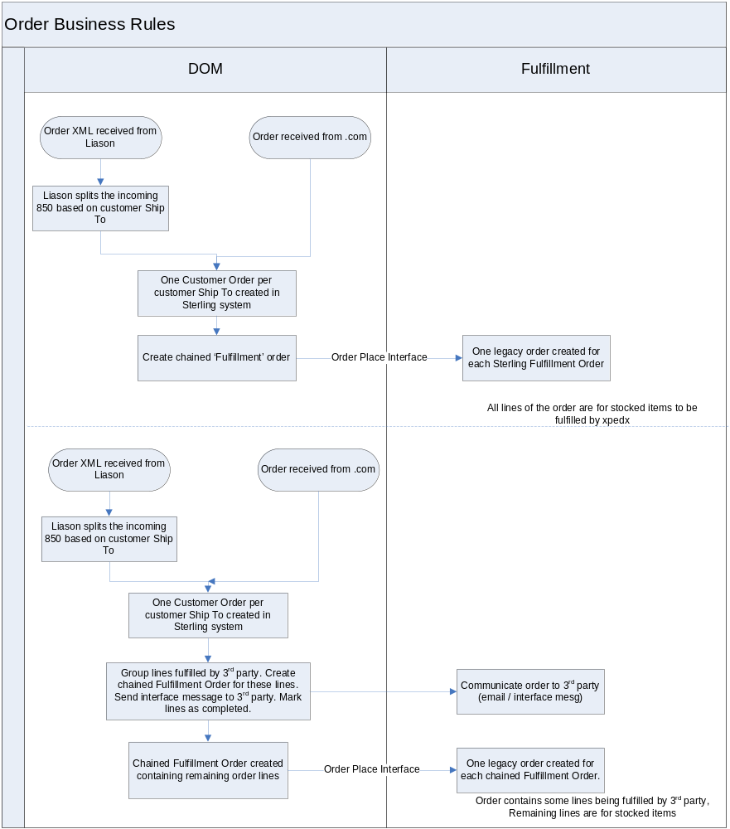

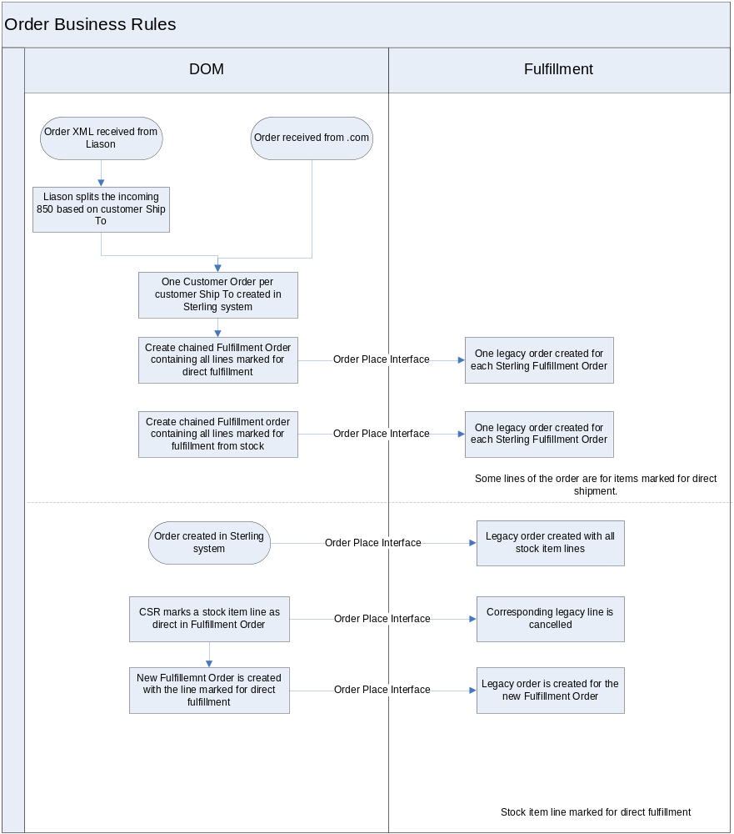

Flow Details

A line on the order can be classified as STOCK, DIRECT or 3RDPARTY depending on how it is processed at the branch fulfilling the order.
The item-branch tables are queried to see if there is a record for the item at branch fulfilling the order. The record will indicate whether the item will be fulfilled out of stock or the item will be fulfilled direct.
If a record in the item-branch table is not present, the Sterling catalog is queried to see if the item is present. If it is, then it is treated as a 3PL item. If it is not present in catalog, then it is treated as a special item. Currently both 3PL items and special items are treated as STOCK items.
The following table documents the logic used to determine the fulfillment method for the item.

Sterling Catalog | Item – Branch Record | Item Type
Y | Stock | STOCK
Y | Direct | DIRECT
Y | No | Special
N | No | Special
Y – Flagged as 3PL | N | 3PL

If a Customer Order contains lines with items which are marked for fulfillment by a third party, it will result in the creation of two Fulfillment Orders assuming that all the remaining lines are for items which are stocked. One Fulfillment Order will contain all the lines being fulfilled by the third party. The other will contain lines which are fulfilled by xpedx.
The first Fulfillment Order will result in an email to the third party organization. After that, all the lines in that order will be marked as completed.
The second Fulfillment Order will result in an order place on the legacy system.

An item may be classified as a direct ship item. If a Customer Order contains lines containing items classified as direct ship items, it results in creation of two Fulfillment Orders assuming that all the remaining lines are for items which are stocked. One order contains all the lines with items classified as direct ship items. The other contains lines with items marked as stock items. This results in the placement of two orders on the legacy system.

A CSR may choose to update a line marked for fulfillment from stock to a line marked for direct fulfillment. On updating the line from fulfillment from stock to direct fulfillment on the Fulfillment Order the following events occur –

- The corresponding line on the ‘Stock Fulfillment’ order is cancelled. This results in the cancellation of the line on the legacy order via a message on the Order Place Interface.
- A new chained ‘Direct Fulfillment’ order is created with only the corresponding line. The line is marked for direct fulfillment.
- This results in an order placement on the legacy system via the Order Place Interface.

Field Mapping

N.A.

Schema

N.A.

Screen Shot

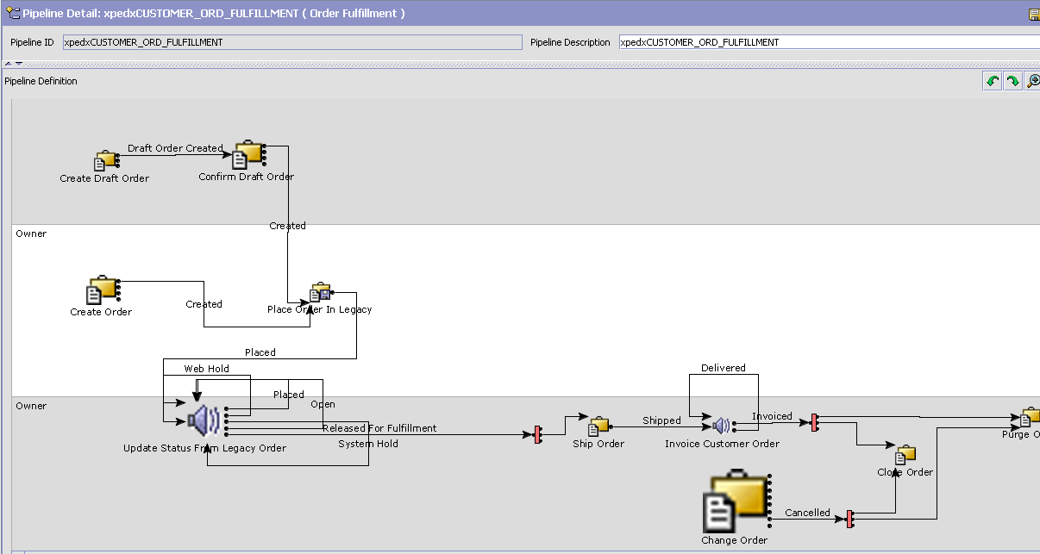

Pipeline for Customer Order

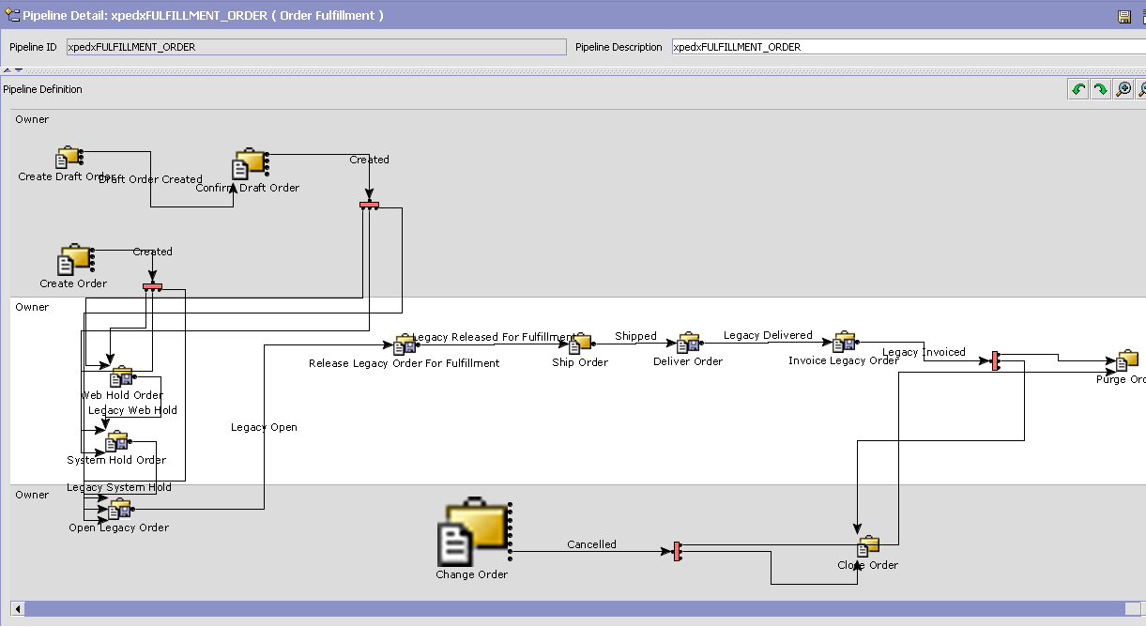

Pipeline for Fulfillment Order

Open Questions
- The logic for identifying an item as a 3PL item needs to be finalized.

Assumptions
- Any updates to the line type on an order will happen on the Fulfillment Order and not on the Customer Order.

Connectivity Diagram

N.A.

Glossary of Terms

S. No. | Term | Definition
1. | Liason | Third party company responsible for converting the inboundEDI messages to xCBL format
2. | 3PL | Third Party Logistics
3.
4.
5.
6.

